**Question 1**

Write a PHP script to get the PHP version and configuration information.

Code:

<html>

<head>

<title>ws7_1</title>

</head>

<body>

<?php phpinfo();?>

</body>

</html>

Output:

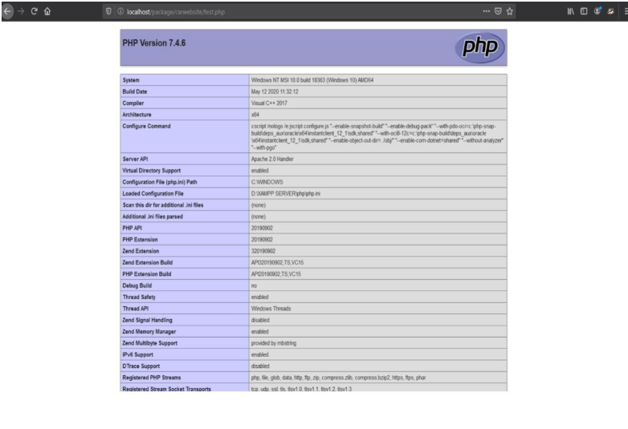

**Question 2**

Create a PHP script that displays 1-2-3-4-5-6-7-8-9-10 on one line. There will be no hyphen(-) at starting and ending position

Code:

<html>

<head>

<title>ws7_2</title>

</head>

<body>

<h1>Printing from 1-10 with a hyphen in between</h1>

<?php

for ($i=1; $i < 10 ; $i++)

{

echo $i . "-";

}

echo "10";

?>

</body>

</html>

Output:

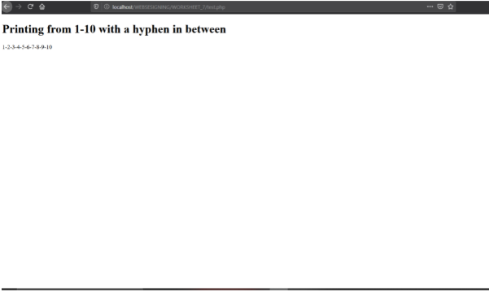

**Question 3**

Write a PHP program to keep track of the number of visitors visiting the web page and display the count of visitors with proper headings.

Code:

<?php

session_start();

if(isset($_SESSION['views']))

$_SESSION['views'] = $_SESSION['views']+1;

else

$_SESSION['views']=1;

?>

<html>

<head>

<title>ws7_3</title>

</head>

<body>

<h1>This site is visited <?= $_SESSION['views'] ?> times.</h1>

</body>

</html>

Output:

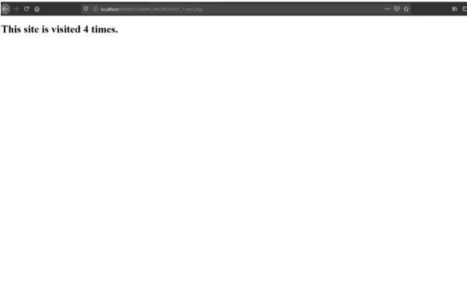

**Question 4**

Write a PHP program to display a digital clock which displays the current time of the server

Code:

<?php

$arr = localtime(time(),true);

$time = $arr["tm_hour"] . ":" . $arr['tm_min']. ":" . $arr['tm_sec'];

header("refresh: 1 ");

?>

<html>

<head>

<title>ws7_4</title>

</head>

<body>

<h1>The Time at the server is <?= $time?> in the form of h:m:s.</h1>

</body>

</html>

Output:

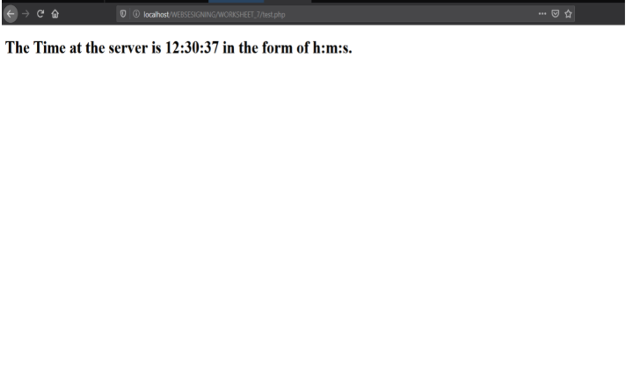

**Question 5**

Write a PHP script that removes the whitespaces from a string

Code:

<?php

$var;

if(isset($_GET['sentence']))

{

$arr = str_split($_GET['sentence']);

$var = $arr[0];

for ($i=0; $i < count($arr); $i++)

{

if($arr[$i] == " ")

{

array_splice($arr, $i, 1);

}

}

$var = implode("",$arr);

}

?>

Output:

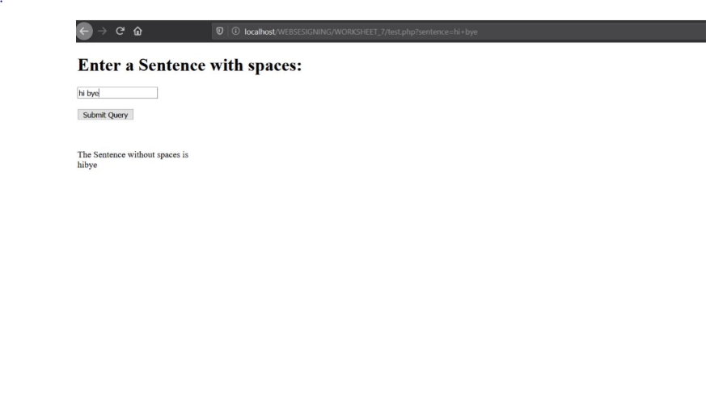

**Question 6**

Write a PHP function that checks whether a passed string is palindrome or not? A palindrome is word, phrase, or sequence that reads the same backward as forward, e.g., madam or nurses run.

Code:

<html>

<head>

<title>ws7_6</title>

</head>

<body>

<h1>Enter a Sentence with spaces:</h1>

<form>

<input type = "text" name = "sentence" placeholder="Write a sentence "><br><br>

<input type="submit">

</form><br>

<?php

if(isset($_GET['sentence']))

{

echo "<p> The Sentence without spaces is <br>" . $var . "</p>";

}

?>

</body>

</html>

**Question 7**

Write a PHP function that checks whether a passed string is palindrome or not? A palindrome is word, phrase, or sequence that reads the same backward as forward, e.g., madam or nurses run.

Code:

<?php

$var;$ans;

$is_palindrome = true;

if(isset($_GET['sentence']))

{

$arr = str_split($_GET['sentence']);

for ($i=0; $i < count($arr); $i++)

{

if($arr[$i] == " ")

{

array_splice($arr, $i, 1);

}

}

$var = implode("",$arr);

echo $var;

$arr_2 = str_split($var);

$j = count($arr_2)-1;

for ($i=0; $i < $j; $i++)

{

if($arr_2[$i] != $arr_2[$j])

{

$is_palindrome = false;

break;

}

$j--;

}

if($is_palindrome)

{

$ans = "is a Palindrome";

}

else

{

$ans = "is NOT a Palindrome";

}

}

?>

<html>

<head>

<title>ws7_7</title>

</head>

<body>

<h1>Enter a Sentence and press check to know if it is a Plindrome</h1>

<form>

<input type = "text" name = "sentence" placeholder="Write a sentence "><br><br>

<input type="submit" value="Check">

</form><br>

<?php

if(isset($_GET['sentence']))

{

echo "<p> The Sentence/Word " . $ans . "</p>";

}

?>

</body>

</html>

Output:

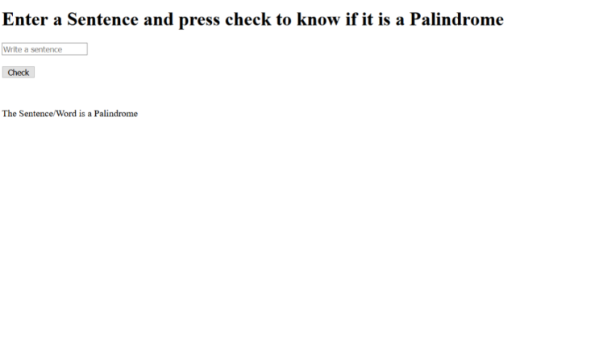

**Question 8**

Write a PHP script to sort the following associative array using functions: array("Sophia"=>"31","Jacob"=>"41","William"=>"39","Ramesh"=>"40") in

a) ascending order sort by value b) ascending order sort by key

c) descending order sorting by value

d) descending order sorting by key]

Code:

<?php

$array = array ("Sophia"=>"31","Jacob"=>"41","William"=>"39","Ramesh"=>"40");

echo "<h1> Original Array</h1><pre>";

var_dump($array);

echo "</pre>";

?>

<html>

<head>

<title>ws7_8</title>

</head>

<body>

<h1>Ascending order sort by value</h1>

<pre>

<?php

asort($array);

var_dump($array);

?>

</pre>

<h1>Ascending order sort by key</h1>

<pre>

<?php

ksort($array);

var_dump($array);

?>

</pre>

<h1>Descending order sorting by value</h1>

<pre>

<?php

arsort($array);

var_dump($array);

?>

</pre>

<h1>Descending order sorting by key</h1>

<pre>

<?php

krsort($array);

var_dump($array);

?>

</pre>

</body>

</html>

Output:

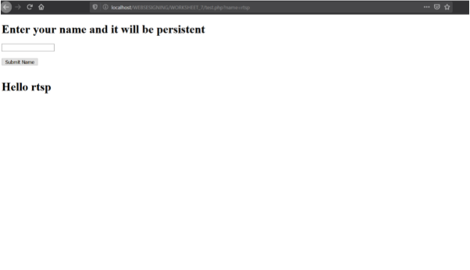

**Question 9**

Write a PHP script to store and retrieve persistent data across a client session

Code:

<?php

if(!isset($_SESSION['name']))

{

if(isset($_GET['name']))

{

$_SESSION['name'] = $_GET['name'];

}

}

?>

<html>

<head>

<title>ws7_9</title>

</head>

<body>

<h1>Enter your name and it will be persistent</h1>

<form>

<input type = "text" name = "name" ><br><br>

<input type="submit" value="Submit Name">

</form>

<?php

if(isset($_SESSION['name']))

{

echo "<br><h1>Hello {$_SESSION['name']}</h1>";

}

?>

</body>

</html>

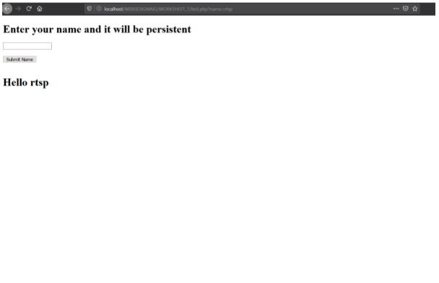

**Question 10**

Write a PHP script to simulate the Shopping Cart, allow users to select items from a catalog and save them for later access using session.

Code:

<?php

session_start();

if(isset($_SESSION['name']))

{

$_SESSION['name'] .= " " . $_GET['name'];

}

else

{

if(isset($_GET['name']))

{

$_SESSION['name'] = $_GET['name'];

}

}

?>

<html>

<head>

<title>ws7_10</title>

</head>

<body>

<h1>Enter your our item</h1>

<form>

<input type = "text" name = "name" ><br><br>

<input type="submit" value="Add Item">

</form>

<?php

if(isset($_SESSION['name']))

{

echo "<br><h1>Your Cart items<br> {$_SESSION['name']}</h1>";

}

?>

</body>

</html>

Output:

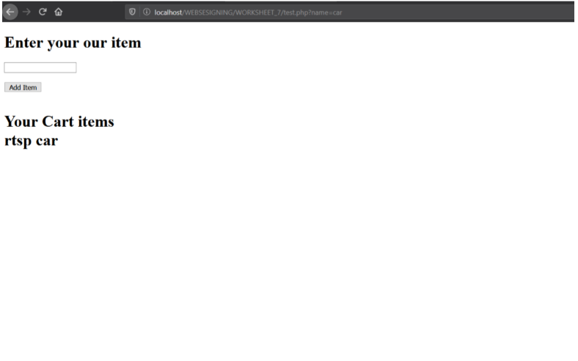

**Question 11**

Write a PHP script to store and retrieve cookies in a web page.

Code:

<?php

if(isset($_GET['name']))

{

setcookie("cookie",$_GET['name']);

}

?>

<html>

<head>

<title>ws7_11</title>

</head>

<body>

<h1>Enter your name ( persisted by cookie )</h1>

<p>Reload to see your name displayed</p>

<form>

<input type = "text" name = "name" ><br><br>

<input type="submit" value="Enter!!">

</form>

<?php

if(isset($_GET['name']))

{

echo "Cookie is {$_COOKIE['cookie']}";

}

?>

</body>

</html>

Output:

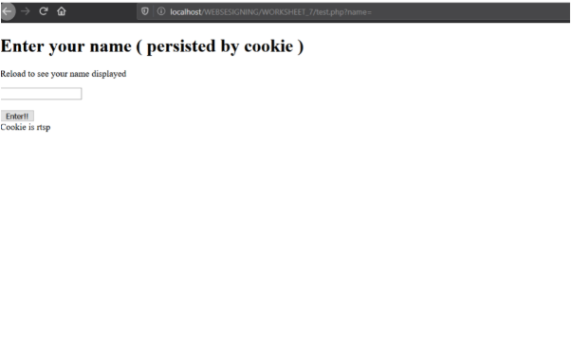

**Question 12**

Write a PHP script named states.php that creates a variable $states with the value "Mississippi Texas Massachusetts Kansas". The script should perform the following tasks: a) Search for a word in $states that ends in xas. Store this word in element 0 of an array named $statesArray. b) Search for a word in $states that begins with k and ends in s. Perform a case-insensitive comparison. Store this word in element 1 of $statesArray. c) Search for a word in $states that begins with M and ends in s. Store this element in element 2 of the array. d) Search for a word in $states that ends in a. Store this word in element 3 of the array. e) Search for a word in $states at the beginning of the string that starts with M. Store this word in element 4 of the array. f) Output the array $statesArray to the screen.

Code:

<html>

<head>

<title>ws7_12</title>

</head>

<body>

<?php

$states="Mississippi Texas Massachusetts Kansas";

$end=strpos($states,"xas")+2;

$start=strrpos($states," ",$end-strlen($states) );

$statesArray[0]=substr($states,$start,$end-$start+1);

$start=stripos($states,"k");

$end=stripos($states,"s",$start);

$statesArray[1]=substr($states,$start,$end-$start+1);

$start=strpos($states,"M");

$end=strpos($states,"s",$start);

$statesArray[2]=substr($states,$start,$end-$start+1);

$end=strpos($states,"a");

$start=strrpos($states," ",$end-strlen($states) );

$statesArray[3]=substr($states,$start,$end-$start+1);

$start=strpos($states,"M");

$end=strpos($states," ",$start);

$statesArray[4]=substr($states,$start,$end-$start+1);

foreach($statesArray as $x)

{

echo $x."<br>";

}

?>

</body>

</html>

Output:



**Question 13**

Write a PHP script that tests whether an e-mail address is input correctly. Verify that the input begins with series of characters, followed by the @ character, another series of characters, a period (.) and a final series of characters. Test your program, using both valid and invalid e-mail addresses.

Code:

<?php

if(isset($_GET["email"] ))

{

$email = $_GET["email"];

if (!filter_var($email, FILTER_VALIDATE_EMAIL))

{

$emailmsg = "Invalid email format";

}

else

{

$emailmsg = "Valid email format";

}

}

?>

<html>

<head>

<title>ws7_13</title>

</head>

<body>

<h1>Email validation</h1>

<form>

<input type = "text" name = "email" placeholder="Enter a email"><br><br>

<input type="submit">

</form><br><br>

<?php

if(isset($_GET["email"] ))

{

echo "$emailmsg";

}

?>

</body>

</html>

Output:

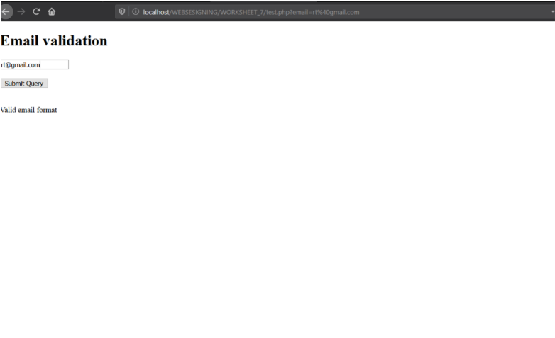

**Question 14**

Write a PHP program to sort the student records which are stored in the database using selection sort

Code:

<?php

$conn= mysqli_connect("localhost", "rtsp", "qwerty", "students");

if (!$conn)

{

echo "Error: " . mysqli_connect_error();

}

else

{

$sql = "SELECT * FROM name";

$retval = mysqli_query($conn,$sql);

$name = array();

$row;

$i = 0;

while ($row = mysqli_fetch_assoc($retval))

{

$name[$i] = $row['name'];

$i++;

}

asort($name);

}

?>

<html>

<head>

<title>ws7_14</title>

</head>

<body>

<h1>Sorting elements acquired from Database</h1>

<?php

echo "<P><B>Array after sorting is</b></p>";

echo "<pre>";

var_dump($name);

echo "</pre>";

?>

</body>

</html>

Output:

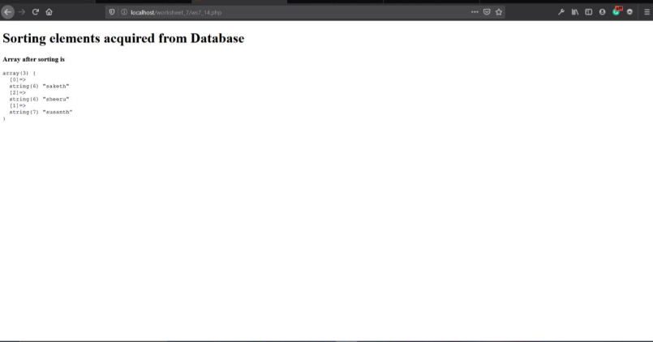

**Question 15**

Write a PHP script that obtains a URL and its description from a user and stores the information into a database using MySQL. Create and run a SQL script with a database named URL and a table named URL Table. The first field of the table should contain an actual URL, and the second, which is named Description, should contain a description of the URL. Use www.deitel.com as the first URL, and input ‘Cool site!’ as its description. The second URL should be www.php.net, and the description should be ‘The official PHP’ site. After each new URL is submitted, print the contents of the database in a table.

Code:

<?php

if(isset($_GET['url']))

{

$conn= mysqli_connect("localhost", "rtsp", "qwerty", "URL");

if (!$conn)

{

echo "Error: " . mysqli_connect_error();

}

else

{

$sql = "INSERT INTO URLTable(url, description) VALUES('$_GET[url]', '$_GET[des]')";

if (mysqli_query($conn, $sql))

{

alert("hello");

}

else

{

echo "Error: " . $sql. "<br>" . mysqli_error($conn);

}

}

}

?>

<html>

<head>

<title>ws7_15</title>

<style>

table,th,td,tr

{

border: 1px solid black;

}

</style>

</head>

<body>

<h1>Adding elements into Database and then displaying them</h1>

<form>

<h3>Enter the URL</h3>

<input type = "text" name = "url" placeholder="Enter the url ">

<h3>Enter the Description</h3>

<input type = "text" name = "des" placeholder="Enter the description "><br><br>

<input type="submit">

</form>

<?php

if(isset($_GET['url']))

{

$sql = "SELECT * FROM URLTable";

$retval = mysqli_query($conn,$sql);

$row;

echo "<h2>Table of the url's</h2>";

echo "<table>";

echo "<tr>";

echo "<th>URL</th>";

echo "<th>Description</th>";

echo "</tr>";

while ($row = mysqli_fetch_assoc($retval))

{

echo "<tr>";

echo "<td>$row[url]</td>";

echo "<td>$row[description]</td>";

echo "</tr>";

}

echo "</table>";

}

?>

</body>

</html>

Output:

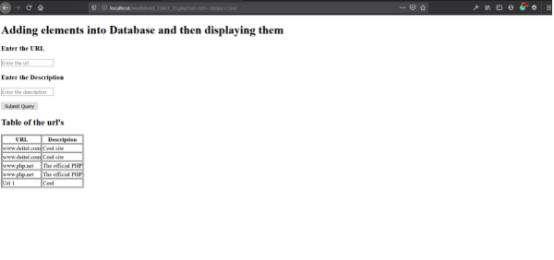

**Question 16**

Develop a PHP program to authenticate users with a valid User Id and Password before granting access to a protected resource

Code:

<?php

$isValid = "false";

if(isset($_POST['user']))

{

$conn= mysqli_connect("localhost", "rtsp", "qwerty", "ws7_16");

if (!$conn)

{

echo "Error: " . mysqli_connect_error();

}

else

{

$sql = "SELECT * FROM user_details";

$retval = mysqli_query($conn,$sql);

$row;

while ($row = mysqli_fetch_assoc($retval))

{

if ($_POST['user'] == $row['username'] && ($_POST['password'] == $row['password']))

{

$isValid = "true";

}

}

}

}

?>

<html>

<head>

<title>ws7_16</title>

</head>

<body>

<h1>Verification process</h1>

<form method="post">

<h3>Enter the User Id</h3>

<input type = "text" name = "user" placeholder="Enter the user-id ">

<h3>Enter the Password</h3>

<input type = "password" name = "password" placeholder="Enter the password "><br><br>

<input type="submit">

</form>

<?php

if(isset($_POST['user']))

{

if ($isValid == "true")

{

echo "<P>Username and Password are validated and the given cred is CORRECT</P>";

}

else

{

echo "<p>Username and Password are validated and the given cred is INCORRECT</p>";

}

}

?>

</body>

</html>

Output:

